Low Level Design (LLD)

Entertainer Data Analysis

Last date of revision: 27/05/2024

Divakar K G

[AUTHOR NAME] 1

**Document Version Control**

**Date Issued**

**Version**

**Description**

**Author**

**27th May 2024**

1.0

First Version of Complete LLD

Divakar K G



Table of Contents

1. Introduction 4

1.1 What is Low-Level design document? 4

1.2 Scope 4

Project Introduction: 4

Problem Statement: 4

Dataset Description: 5

Provided Dataset: 5

1. Entertainer-Basic Info 5

2. Entertainer-Breakthrough Info: 5

3. Entertainer-Last major work Info: 5

Populated Dataset: 5

Data populating flow 6

Architecture 6

Deployment 8

# 

# 1. Introduction

## What is Low-Level design document?

The goal of the LDD or Low-level design document (LLDD) is to give the internal logic design of the actual program code for the House Price Prediction dashboard. LDD describes the class diagrams with the methods and relations between classes and programs specs. It describes the modules so that the programmer can directly code the program from the document.

## 1.2 Scope

Low-level design (LLD) is a component-level design process that follows a step-by-step refinement process. The process can be used for designing data structures, required software architecture, source code and ultimately, performance algorithms. Overall, the data organization may be defined during requirement analysis and then refined during data design work.

# Project Introduction:

Entertainment Industry plays a major role in our day-to-day life, from how we talk to how we dress and how we behave in our life is largely influenced by movies and series. No matter what, we all have at least one close to heart movie or star because of some specific reason or without any reason also. People never missed to celebrate good movies and stars, maybe it was celebrated bit late, but obviously it will be celebrated if the work is genuine. As we all know, it’s a very competitive career filed and it takes a great effort to sustain the in the industry as a star or technician or producer. This analysis is aimed to analysis the entertainer’s filmography, awards and compare film over the years in different aspects and get insights out of it.

# 

# Problem Statement:

Normal life can be stressful, and people need to relax. Being entertained by others is a wonderful way to take some time out of life. It can reduce stress and make life's issues easier to face. The media and entertainment industry consists of film, television, radio and print. These segments include movies, TV shows, radio shows, news, music, newspapers, magazines, and books. Entertainment industry is a group of sub-industries devoted to entertainment. Entertainment industry is used to describe the mass media companies that control the distribution and manufacture of mass media entertainment.

# Dataset Description:

## 

## Provided Dataset:

1. Entertainer-Basic Info: It consists of list of **70** Entertainers Name, Birth year and Gender
2. Entertainer-Breakthrough Info: It consists of details about the 70 entertainers like breakthrough year, first major award, breakthrough movie name
3. Entertainer-Last major work Info: It consists of the details about the 70 entertainers last major work and if died, Year of death details.

LINK:Final Combined DataSet

## Populated Dataset:

Entertainer: Name of the entertainer.

Gender (traditional): Traditional gender of the entertainer.

Birth Year: Year the entertainer was born.

Year of Breakthrough: Year the entertainer had their first big hit or major nomination.

Breakthrough Name: Name of the breakthrough project.

Director: Director of the breakthrough project.

Breakthrough Image: Cover image of the breakthrough project.

Year of First Oscar/Grammy/Emmy: Year the entertainer won their first major award.

Headshot: Headshot of the entertainer.

Height: Height of the entertainer.

Number of Films Acted In: Total number of films the entertainer has acted in.

Quote: Famous quote by the entertainer.

Award Won from Breakthrough: Award won from the breakthrough project.

Total Awards Won: Total number of awards won.

Total Nominations: Total number of award nominations.

Profession: Entertainer's profession (e.g., actor, singer).

Oscar Won: Number of Oscars won.

Grammy Won: Number of Grammys won.

Emmy Won: Number of Emmys won.

Other Awards Won: Number of other awards won.

Average Rating: Average rating of the entertainer's films.

# Data populating flow

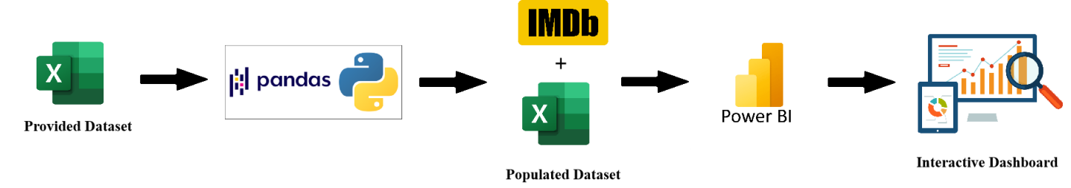

# Architecture

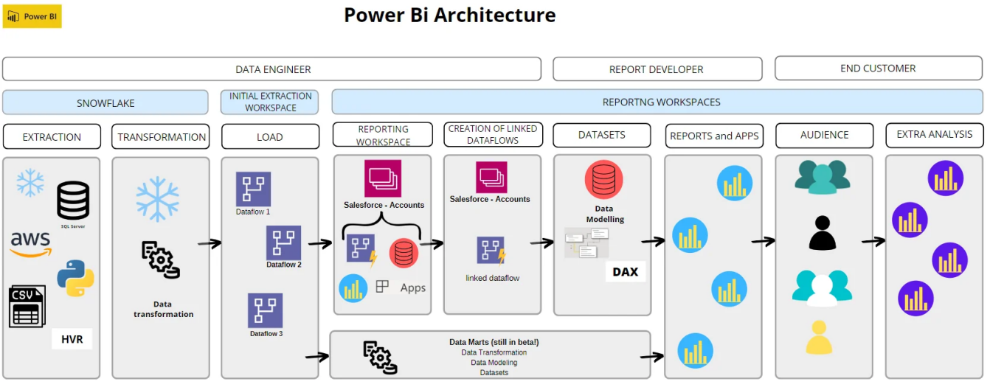

## 

## Data sources:

* iNeuron provided dataset: 3 Excel files of the Entertainers details
* Populated data using Kaggle Dataset for Imdb 1888 -2023.

## Data connection:

Connecting all the data sources and importing the data into the PowerBi

## ETL:

Extra, Load and Transform will be performed for the imported datasets in the PowerQuery editor.

* Data type change
* Duplicate Handling
* Date type
* Merge/ Append tables based on the need

## 

## Data modelling:

Data Modelling is the process of analyzing the data objects and their relationship to the other objects. It is used to analyze the data requirements that are required for the business processes. The data models are created for the data to be stored in a database. The Data Model's main focus is on what data is needed and how we have to organize data rather than what operations we have to perform.

## Report Building:

Report will be designed based on the mock ups which were created in the initial stage of the project. Reporting is a most important and underrated skill of a data analytics field. Because being a Data Analyst you should be good in the easy and self- explanatory report because your model will be used by many stakeholders who are not from a technical background.

● High-Level Design Document (HLD)

* ● Low Level Design Document (LLD)
* ● Architecture
* ● Wireframe
* ● Detailed Project Report

**Deployment**

When it comes to analyzing and visualizing data for improved comprehension, many companies and organizations turn to advanced business intelligence technologies, with Power BI emerging as a standout solution. With its array of services, Power BI offers robust tools for data analysis and visualization.

Specifically, Power BI Desktop is renowned for its accessibility and affordability—it's free for anyone to utilize. By harnessing Power BI Desktop, users can craft engaging visuals and dashboards that are seamlessly integrated with Power BI's cloud service. This facilitates easy sharing and collaboration, as users can distribute shareable links to grant access to specific reports or analyses.

